The Lightweight IBM Cloud Garage Method for Data Science

Architectural Decisions Document Template

# Architectural Components Overview

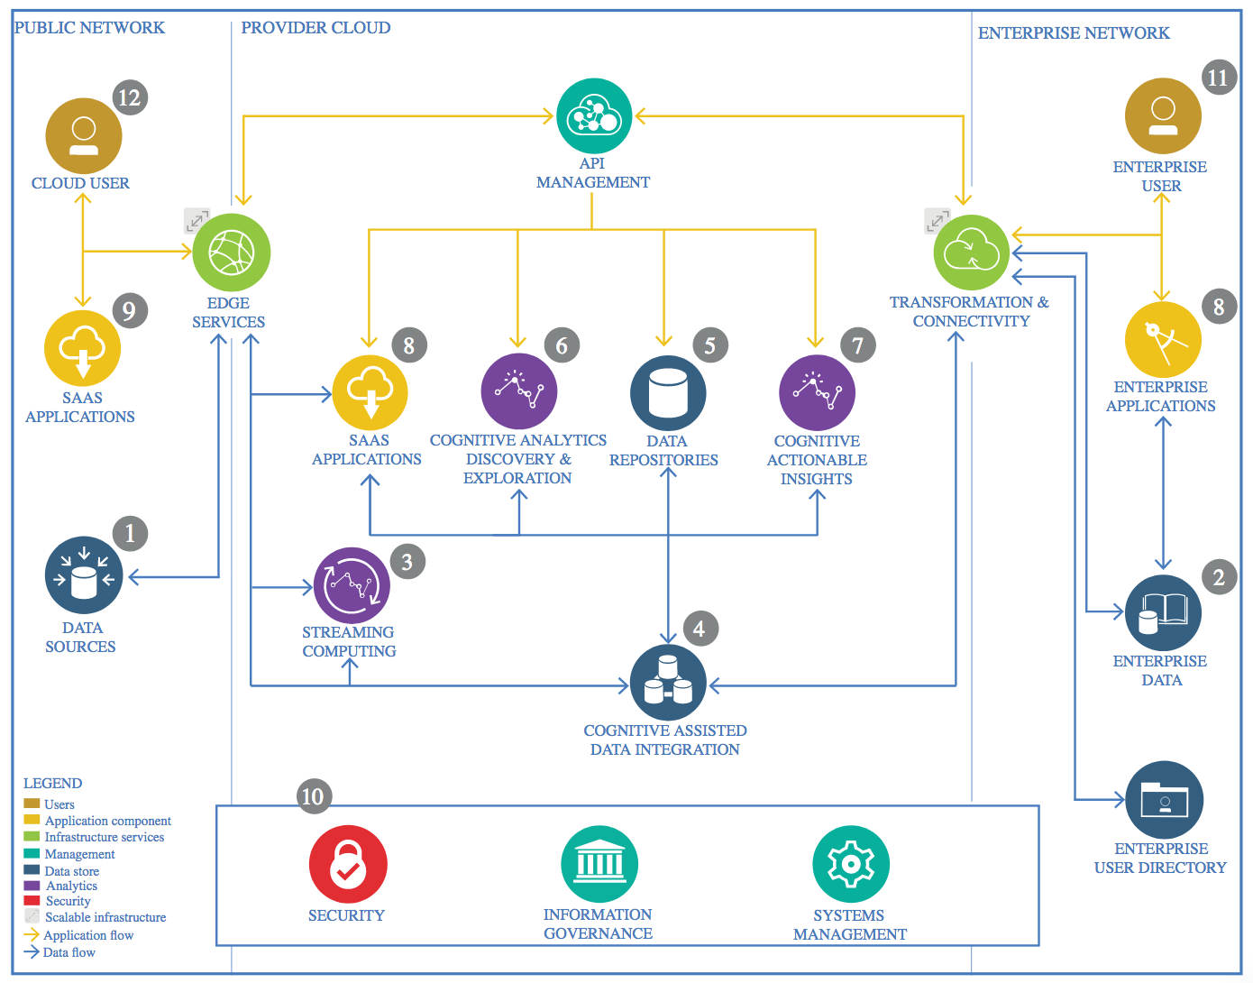

IBM Data and Analytics Reference Architecture. Source: IBM Corporation

## Data Source

### Technology Choice

Please describe what technology you have defined here. Please justify below, why. In case this component is not needed justify below.

### Justification

Please justify your technology choices here.

## Enterprise Data

### Technology Choice

Please describe what technology you have defined here. Please justify below, why. In case this component is not needed justify below.

### Justification

Please justify your technology choices here.

## Streaming analytics

### Technology Choice

Please describe what technology you have defined here. Please justify below, why. In case this component is not needed justify below.

### Justification

Please justify your technology choices here.

## Data Integration

### Technology Choice

Please describe what technology you have defined here. Please justify below, why. In case this component is not needed justify below.

### Justification

Please justify your technology choices here.

## Data Repository

### Technology Choice

Please describe what technology you have defined here. Please justify below, why. In case this component is not needed justify below.

### Justification

Please justify your technology choices here.

## Discovery and Exploration

### Technology Choice

Please describe what technology you have defined here. Please justify below, why. In case this component is not needed justify below.

### Justification

Please justify your technology choices here.

## Actionable Insights

### Technology Choice

Please describe what technology you have defined here. Please justify below, why. In case this component is not needed justify below.

### Justification

Please justify your technology choices here.

## Applications / Data Products

### Technology Choice

Please describe what technology you have defined here. Please justify below, why. In case this component is not needed justify below.

### Justification

Please justify your technology choices here.

## Security, Information Governance and Systems Management

### Technology Choice

Please describe what technology you have defined here. Please justify below, why. In case this component is not needed justify below.

### Justification

Please justify your technology choices here.